Week in Review - March 22-29
Alex Shvartsman

NEXT SEASON'S PRO TOUR SCHEDULE UNVEILED

The tentative schedule for the 2001-2002 Pro Tour stops has been posted on the Wizards of the Coast web site, here.
Pro Tour will return to New York's Madison Square Garden in September, where a team event will take place. In November, an Extended Pro Tour will take place in New Orleans.
Instead of returning to Los Angeles, the winter Rochester Draft Pro Tour will take place in sunny San Diego in January. A Block Constructed Pro Tour will once again take place in Japan, this time in the city of Osaka, sometime in the spring. The next Booster Draft Pro Tour will take place somewhere in France in 2002.
Finally, the World Championships next year will take place in Syndey, Australia.
The event schedule also mentions the expansion names to be released next year. The standalone, due out this Autumn, will be called Odyssey. Its follow-up expansions will be Vendetta and Judgment.
Grand Prix schedule for the first several months of the next season has also been posted here.
These schedules are tentative, and are subject to change.

GRAND PRIX GOTHENBURG
GP circuit re-visited Sweden, with 460 people fighting it out for cash and PT points.
The Winners
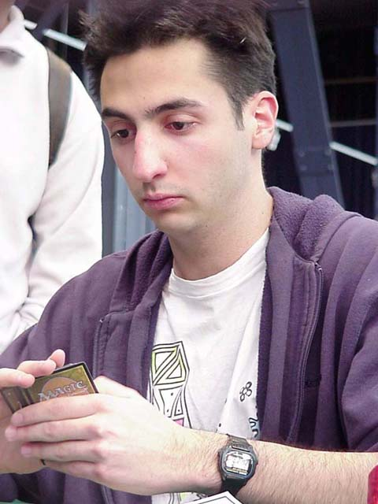
Top 8 of this tournament had virtually none of the high-profile names we've grown accustomed to seeing doing well on the GP circuit. With the exception of Raphael Levy, none of the successful players are particularly well known outside their countries yet - however, this may change. Among the winners this time is a two time Swedish national champion Jimmy Oman, Sideboard reporter Scott Wills, popular Norwegian player Eivind Nitter, and the one well-known competitor in this Top 8, Raphael Levy.
Finals were played between the Netherlands' Joe Schreurs and Denmark's Jesper Thrane. Pro Tour veteran Svend Geertsen credits Thrane as his mentor in playing limited. Thrane made top 8 at GP Copenhagen in 1997 and competed on several Pro Tours. Schreurs did play in several Pro Tours previously as well, but his best finish before this weekend was 26th at the more recent GP Copenhagen, last season. Schreurs won the final match 2-1, to claim his first champion title.
While Top 8 did not feature many well-known players, 9 through 12 were populated by myself, Dominik Hothow, Svend Geertsen and Sigurd Eskeland. Because of a high concentration of qualified players, invitations to PT Barcelona extended all the way down to 18th place.
Player of the Year Race
Neither Pustilnik nor Cornelissen showed up for this tounament, leaving the very top of the race unchanged. Their closest rivals Mowshowitz and Budde both made the trip, and finished within a few places of each other - 25th and 27th, earning one pro point each. Of other players currently in the top 10 of the race, only Ryan Fuller showed up, but failed to make Day 2.
Best Sealed Deck Ever?
Jester Thrane opened what may well be the best sealed deck ever. His black-red deck featured all of the following cards: Blazing Specter, Void, Tahngarth, Flametongue Kavu, Annihilate, Thunderscape Battlemage, Magma Burst, Agonizing Demise and Scorching Lava. These spells mixed well with a selection of black and red creatures. Despite having zero byes, Thrane easily achieved a 6-0-1 record on Day 1. He was not only lucky but good, playing well enough during Day 2 to make Top 8 and then get as far as the finals of the tournament.
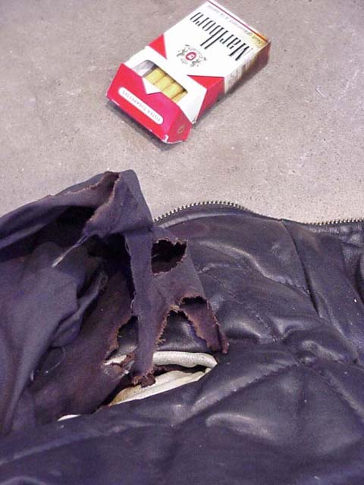
One of the many reasons there is no smoking at the Pro Tour
Player on Fire!
Franck Canu managed to set himself on fire, because of a cigarette he did not extinguish properly before putting in his pocket! A burning smell alerted Canu to the problem in time for him to put out the smoldering inside of his jacket before it became really serious. Canu was not hurt, but his leather jacket now features a small hole, and his ego a large one.

COMING UP: GP DETROIT

This is the very last chance to qualify for Pro Tour Barcelona, and many players will be traveling to Detroit by plane, train and automobile to try. Pustilnik, who is becoming notorious for skipping Grand Prix, will show up this time, as will Zvi Mowshowitz. Cornellisen and Budde are not expected, though as of last weekend Ryan Fuller was seriously thinking about it. Whatever actually happens there, Detroit is guaranteed to be an interesting, and hard tournament.
If you plan to attend, check out this handy guide to the city.

MAGIC TRIVIA
Last week's question:
Although Zvi is best known as a deck builder, he won a Pro Tour with a deck designed by a teammate. Even the best of deck builders sometimes succeed with a deck that another player gets most of the credit for building. Here are several tournament winners. Can you figure out what players are credited with designing their decks?
Sigurd Eskeland - Rising Waters - Pro Tour: New York 1999
Bob Maher, Jr. - Oath - Pro Tour: Chicago 1999
Jon Finkel - Black Control - U.S. Nationals 2000
Casey McCarrel - Tinker - Pro Tour: New York 1998
Answers:
Eskeland's deck was designed by now defunct team Mogg Squad, with prime designers for that deck being Seth Burn and Zvi Mowshowitz.
Maher's Oath deck was originally suggested to him by Ped Bun, and originally designed by Michael Stuller.
Finkel's black control deck was designed by Mike Flores - though Jon and others tuned it quite a bit from his original version. The Tinker deck Finkel and Maher both played at the World Championships last year was designed by Steve and Dan O'Mahoney Schwartz.
McCarrel was handed his deck by Team Jumble. I am not sure of the exact design credit, but I believe Ben Rubin may deserve most of the credit on that one.
New question:
(Courtesy of Matt Vienneau)
What enchantment cannot ever be successfully destroyed by Disenchant, even if its laced to become another color?

BEST OF THE NET
Pro Tour Tokyo winner Zvi Mowshowitz's tournament report is now available from Mindripper.

PLAY OF THE WEEK
(Unfortunately, the player who submitted this did not leave his name)
A Counterrebel deck was playing against Machinehead (B/R). The Counterrebel player was at 10 life, while his opponent at 3. CR player was very likely to win. The only card he feared was Urza's Rage, but his opponent only had ten lands. Machinehead player drew and cast a Dark Ritual. With ten lands in play, that could only mean one thing. So the CounterRebel player responded with... Orim's Chant!
Machinehead player could no longer win by casting his Urza's Rage. On top of that, he had no way to spend the three mana he got into his pool after the Ritual resolved, so he ended up burning for 3, losing the game that turn.

BAD PLAY OF THE WEEK
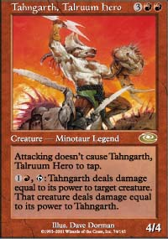
Poor, poor Minotaur Legend
A day before GP Gothenburg, a number of players did a practice draft. I ended up playing in the finals against Pete Norris, fellow Sideboard writer and one of the nice guys who make hanging out at GPs so much fun.
Things looked grim for my G/W/U deck. Norris got out a Tahngarth, which I had virtually no way to deal with. I had to enchant it with Hobble, to buy myself some time and try to find an answer - however, Hobble is clearly a weak answer to Tahngarth! Eventually I drew and played Shackles on a still-untapped Tahngrarth. It would be able to take out one of my creatures, but at least it would remain tapped after that.
Meanwhile, Norris continued his offensive. He summoned a Volcano Imp and enchanted it with Sinister Strength.
After a few attacks, I had no choice but to take back my Shackles and use it to stop the flyer. I returned Shackles to my hand at the end of his turn, and recast it on the Imp during my own turn. Norris saw an opportunity here. "I am going to get rid of your Shackles once and for all," he declared, and tapped Tahngarth to deal 4 damage to his own Imp, in response to me casting Shackles.
Norris apparently forgot the fact that his Imp was 5/2, not 2/2. It dealt five damage back to the Minotaur, taking out two very scary monsters in return for my Shackles going to the graveyard. Worthwhile trade, if you ask me!
Norris paid a lot more attention in the actual tournament, making Day 2 in Gothenburg.
As always, please send good/bad plays, cool trivia questions, and other news to ashv@concentric.net.

